Core Module 1

Question 4 –

I entered first serial number and put the data validity on whole numbers from 1 to 10 for serial number.

Then, I entered the names of the employee.

Then, I gave the date of birth of the employee and put the data validation on the year between 1/1/1999 to 1/1/2005.

Then, I wrote the departments of the employee and gave the data validation on departments, whether they are from Marketing, Sales and Designing.

Then, I put the salary and the data validation on salary was between Rs1000 to Rs50000.

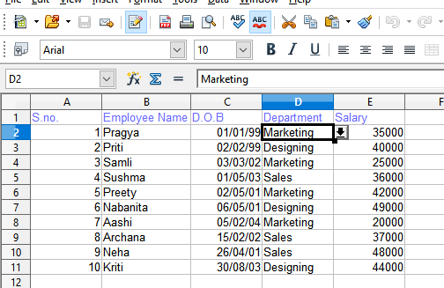

Question 3-

At first, I took one Server, one Router , one Switch and attached two PC from the Switch. Then, I gave IP address to the devices as follows-

PC0- 192.168.2.2

PC1- 192.168.2.3

ROUTER – 192.2.1

10.10.10.1

SERVER – 10.10.10.2

Then I set the default gateway of the following as such-

PC0- 10.10.10.2

PC1- 10.10.10.2

SERVER – 192.168.2.3

Then, I went to the services tab of Server and set a new username as pragya and password as pragya.

Then, I went to PC0 and created a file name called pragya.txt

The, I went to the Command prompt of the PC0 and use the command to ping server. It was successful. Thereafter, I logged into ftp by giving username and password. And then I sent the file pragya.txt to the server by the command ftp > put pragya.txt.

It was successful.

Then, I logged into the server from Command prompt by using the username and password. Then I cross- checked whether the file was transferred by using the command ftp > get pragya.txt.

It was successful.

Then I repeated the process from PC1. And the file pragya.txt was successfully received from the end PC1.

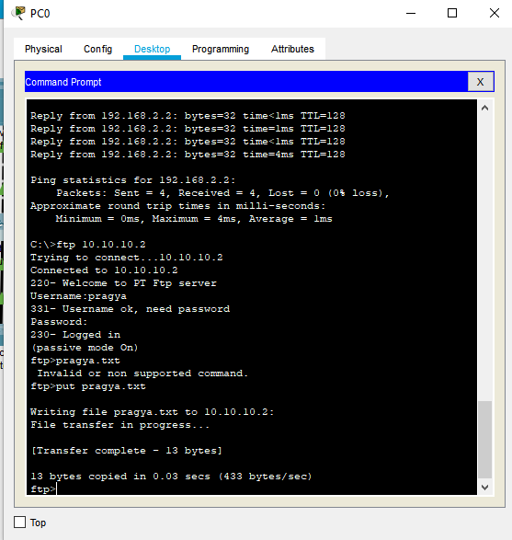

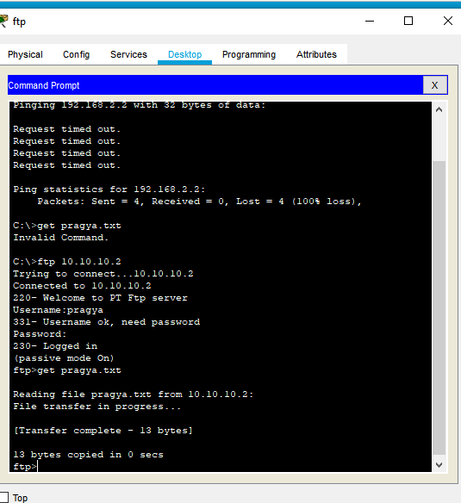

Question 1

I executed the commands as follows-

1. touch pragya – which created a file
2. echo “this is pragya” – which displayed the same line.
3. clear – which cleared all the above commands.
4. ls – which listed all the directories.
5. dir – which listed all the folders.
6. mkdir pragya1 – which created a new folder.
7. cat pragya1 – which displayed pragya1 is a directory.
8. rmdir pragya1 – which deleted pragya1.
9. rm pragya – which deleted pragya.

10. mkdir pragya.

11. mkdir pragya..

12. mkdir pragya…

13. cp –r pragya. Pragya.. – which copied the file pragya. to pragya.. without deleting the first file.

14. mv pragya.. pragya… - which moved the file pragya.. to pragya…

15. find Documents – which listed each folder that was in Documents.

16. touch priti – which created a file priti. And I entered some input in the file.

17. cat priti | head -2 – which displayed the first two lines from the file priti.

18. cat priti | tail -2 – which displayed the last two lines from the file.

19. wc priti – it counted the number of lines, characters and bytes of the file.

20. sort priti – it sorted the file priti in the correct designed way.

